**UML DIAGRAM – EDUSPHERE FUSION**

**SCRUM MASTER:**

MS. NAVYAMOL K T ASSISTANT PROFESSOR

DEPARTMENT OF COMPUTER APPLICATIONS

**SUBMITTED BY:** VISHAL C VISWAM REG. MCA(2022-2024)B ROLL NO:49

**USE CASE DIAGRAM**

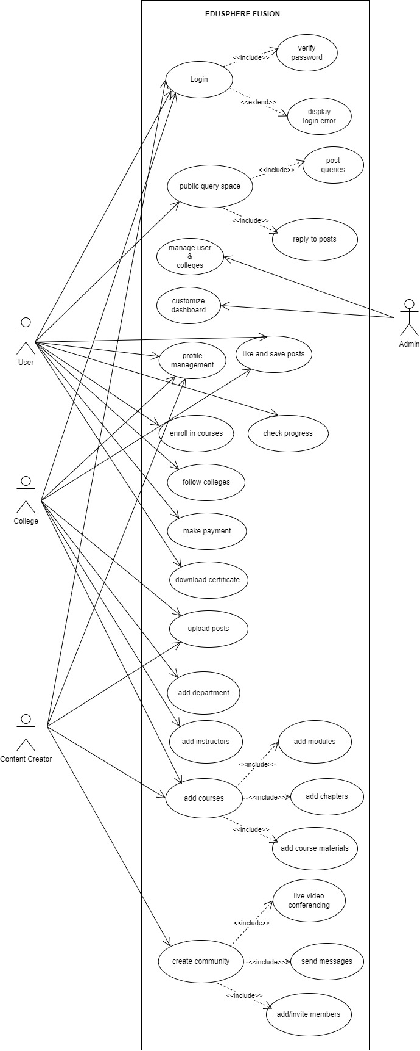

**SEQUENCE DIAGRAM**

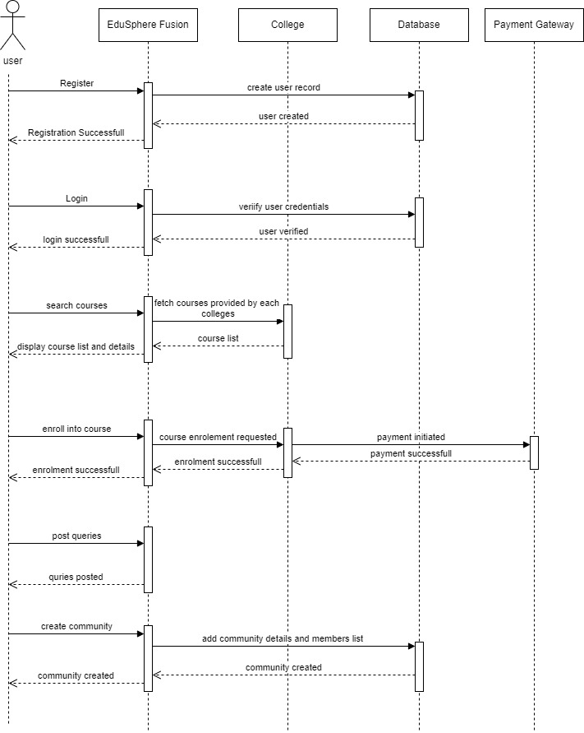

**STATE CHART DIAGRAM**

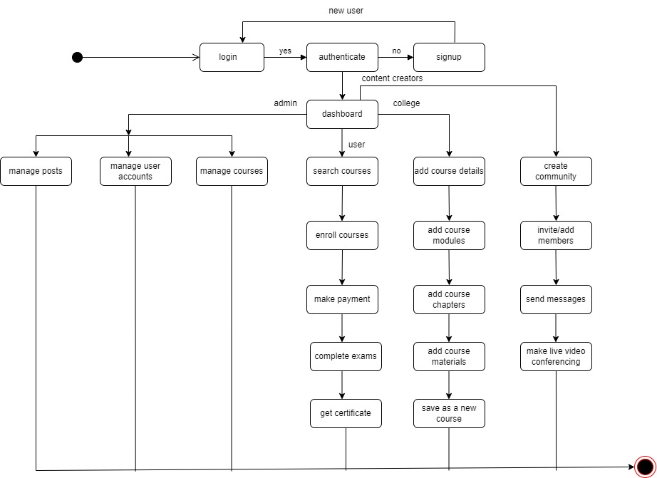

**CLASS DIAGRAM**

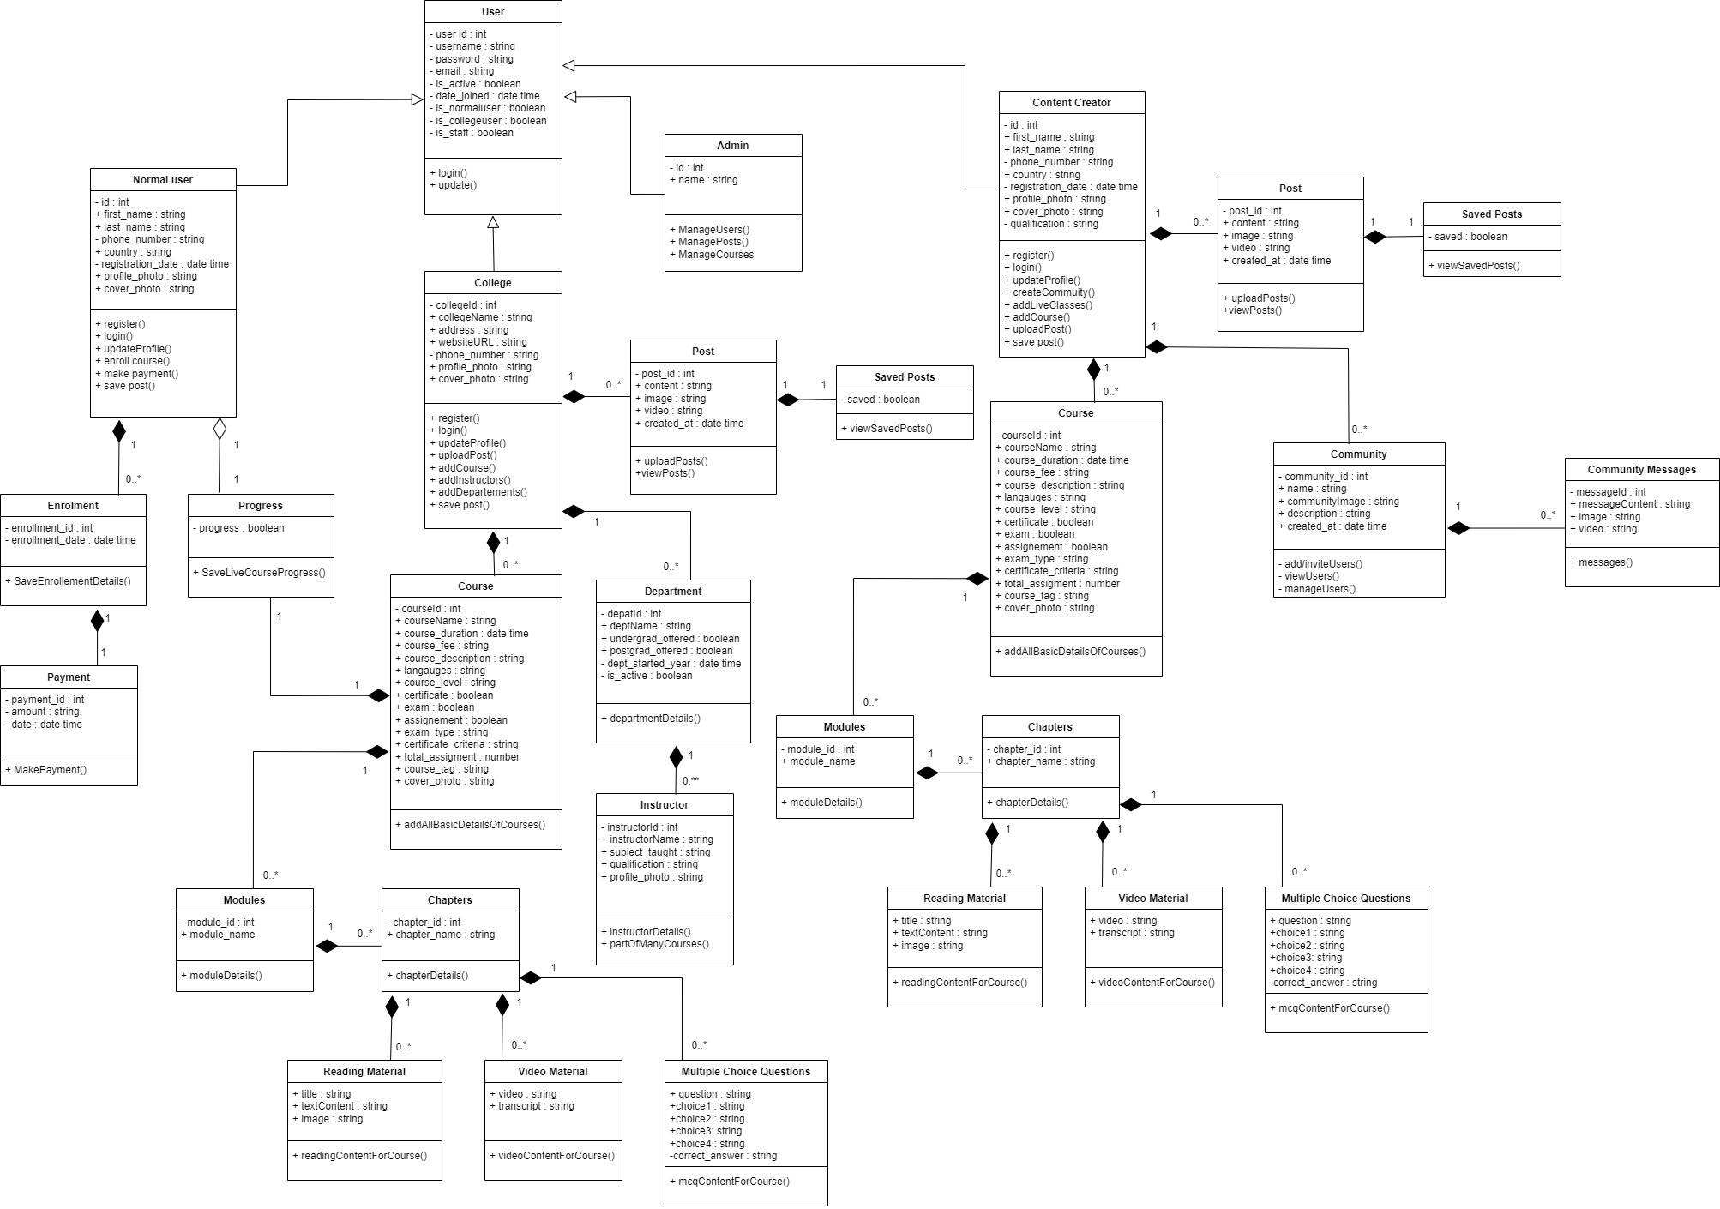

**OBJECT DIAGRAM**

